**Goethe: Chess is “the touchstone of the intellect.”**

(https://www.thearticle.com/the-touchstone-of-intellect)

**Classical Chess game** - it is a mental competition between two partners (opponents, players), between whites and blacks, which takes place on a special table, where chess pieces are moved alternately in a certain order, in accordance with accepted rules. The pieces are often not literally white and black, but usually contrasting light and dark colors.

Chess combines the components of sport, science and art. Chess is a democratic sport where there is age, gender and democracy of personal freedom. Everyone can compete equally. Young with old, man with woman. The key is the player's art of managing chess pieces with strategy. A person can have different life circumstances, but no one can take away a person's freedom to think. We emphasize that **chess is** **freedom to think**.

Each chess game is unique, because on the one hand, the course of the game is determined by the knowledge and experience of the players, the ability to see the square, the strategy of the game, and on the other hand, the player's own connection with the chess game. The chess game can be played with or without a chess clock, with or without recording the moves. The player who has white pieces starts the game. None of the partners has the right to make two moves in a row. What color pieces each partner should play with is determined by the drawing of lot.

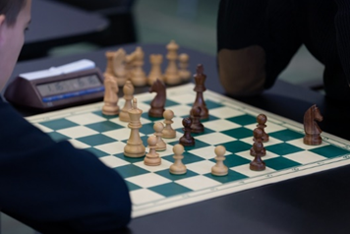

Photo from facebook.com, Latvian Chess Federation

Chess is a universal sport because you can play chess with a computer program or with another opponent remotely, in distance. In such cases, there must be confidence that there will be no cheating - that it will not happen that the principles of the game will be preserved, where only two players play without the help of others. Even if there is nothing available, not a computer, not another opponent, not even a chessboard, you can play chess in your head. If you have the ability to remember the moves of the chess game and how the position changes accordingly, it is possible to play with yourself, play in your head. Such super freedom is chess game!

**Chess history.**

The origins of the game of chess can be found in India. There is a legend how chess was created. According to it in the 6th century AD Sissa Ben Dahir presented a new game to the king Shihram. King was so impressed by complexity and strategical depth of the game, that asked what reward Sissa desired. Sissa replied, that the king could place one grain of wheat (in other sources - rice) to a square, then twice on the second square and double grains until the last 64th square was filled. The king without any doubt agreed to a modest (as he thought) request. The problem appeared when kings servants started to fill squares and quickly realized enormity of Sissa request. The legend is an allegory for the exponential growth of calculation complexity in a game of chess however true origins of chess are more obscure and is likely, that evolution of this table game went through a combination of cultural influences and gameplay innovations in India, Persia, Arab world and later as a final stage of becoming chess as we know it today in Europe.

**Chessboard and chess pieces.**

During the game, the chessboard must be placed between the two opponents so that the white corner square (namely h1 or a8) is located to the right of each player. The chessboard is divided into sixty-four white and black squares, eight in each row. At the beginning of the game, white pieces are always placed in the first and second rows, and black pieces are placed in the seventh and eighth rows. Each piece occupies only one space. It is important to remember that at the beginning of the game, white's queen is always on the white square, and black's queen is always on the black square.

Sixteen pieces stand on each side of the chessboard. The white and black pieces on the table stand symmetrically, facing each other. The pieces are placed as follows: (from the left), The Rook, The Knight, The Bishop, The Queen, The Bishop, The Knight and The Rook. A pawn stands in front of each piece.

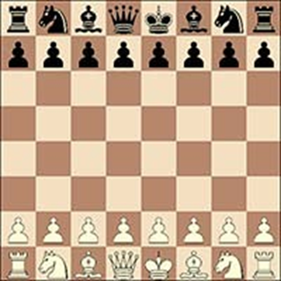 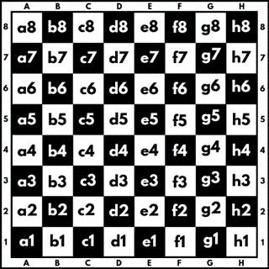

FIDE LAWS of CHESS

Hormuzd Dossabhoy Customize this Contest Square (1:1) Template

<https://www.postermywall.com/index.php/art/template/4237837aecf6058b5c4117fc33166961/chess-notation-game-board-template-design>

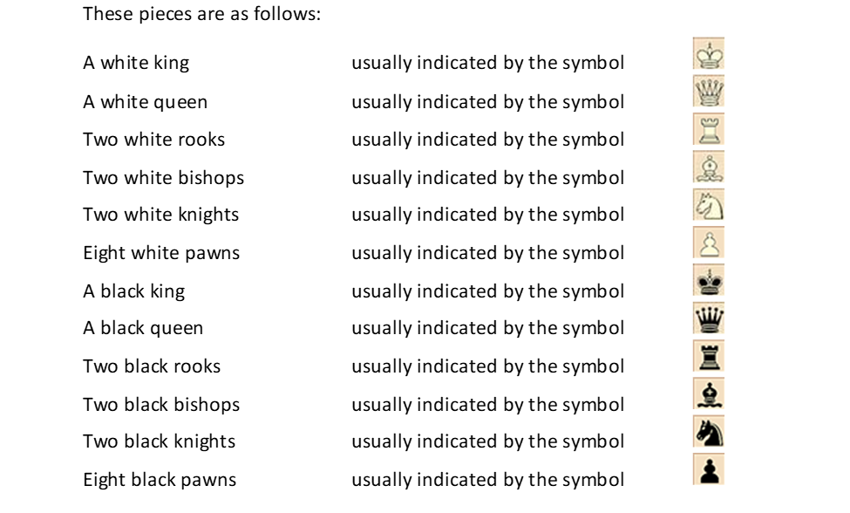

FIDE LAWS of CHESS, chrome-extension://efaidnbmnnnibpcajpcglclefindmkaj/https://www.fide.com/FIDE/handbook/LawsOfChess.pdf

**Basic chess terms.**

**Checkmate**

Checkmate is situation of attack on the king when 3 conditions are met. The king can’t escape, the attacking piece can’t be captured and it is not possible to block the attack. In short, checkmate is an attack on the King that your opponent can’t escape. There are three main ways to win or lose a chess game: checkmate, resignation and timeout.

**Check**

This is also an attack on the king, but unlike checkmate, this is one that your opponent *can*escape.

**Stalemate**

The player to move is not in check, but they can’t move any of their pieces. It is a draw.

**Capture**

Capture refers to taking a piece from the board, so your opponent is a piece down.

**En passant**

A pawn that moves two squares forward can be taken by an opposing pawn that’s directly next to it on the following move.

**Promotion**

A pawn that reaches the end of the board, pawn can be exchanged as part of the same move on the same square for a new queen, rook, bishop or knight of the same colour (just not the king or another pawn).

**Touch move**

If player touches a piece, he has to move it. Once player let go of a piece, the move is made and cannot be taken back.

**The strategy of the chess game: opening, middle game, endgame.**

The main strategy of the game is to develop the pieces, giving the best positions, while at the same time protecting the king. The best chances at the beginning of the game are given by the so-called “opening’s” knowledge. The opening provides tactics for further play. They average 5-15 opening moves that have already been studied by many analysts. Openings are from both whites and blacks. The best opening even after hundreds of years from white’s is probably still 1. e4. White’s must expect that there are many moves to answer the standard e4. Traditionally, e5 can be answered, but the Sicilian defense c5 can be the other the most likely option. Historically chess openings are named after a place/city/region where it was first discovered or played or where the most famous publisher and author came from. In the same time, many variations and openings are named not after the first player, who played it, but after the main influencer and analyst of the variation or opening played (for example: The French Defense, The Italian Game, The London System etc.) There are openings named after the person who played them for the first time or an opening is named for the player who was the first to popularize it or to publish analysis of it (for example Alekhine's Defense, etc.). Sometimes chess openings are even named after animals (for example: Black Lion Defense 1. e4 d6 etc.), and some openings are even given strange names that don't make any sense. The player chooses opening that best suits his character and play style. If a player likes to play in an attacking style, he chooses one opening, if he likes to defend more, the player realizes it in the corresponding opening. The opening is the stage of the game in which players develop their pieces, get their king to safety, and attempt to control the center. After the opening, the game enters the middle game, where the most active action takes place, namely, in the middle game players begin to attack each other, and defend. The endgame is when most of the pieces are off of the board. Each of these stages of the game has developed principles on how best to play to win the game.

Players are given one point (1) for a win, zero point (0) for a loss. The third result that is possible is a draw (1/2).

**Moves of chess pieces.**

**The Rook**

The rook may move to any square along the file or the rank on which it stands (FIDE rules). In other words, the rook moves in a straight line, horizontally and vertically, one or more spaces at a time, unless another piece stands in its way. A rook cannot jump over another figure. If an opponent's piece stands in its way, the rook can capture it by standing in its place. (Kapablanka. Šacha spēles mācība, 1936.)

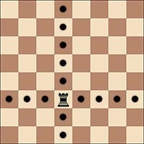

**The Knight**

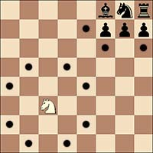The knight move can be described as a compound movement in an ‘L’ shape – two squares vertically and one horizontally, and vice versa. In its move, the knight (white or black) always goes from the white square to the black square or from the black square to the white square, but never the knight can go from the white square to the white square or from the black square to the black square. (Kapablanka. Šacha spēles mācība, 1936.). The knight can capture any piece standing on the end square of the knight's move. The knight is the only piece that can jump over other pieces.

**The Bishop**

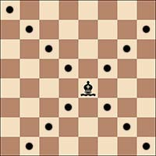The bishop may move to any square along a diagonal on which it stands (FIDE rules). The bishop moves diagonally across one or more squares at a time, if there is no other piece in its diagonal. The bishop cannot jump over other pieces, but bishop can capture another piece. Each bishop is matched with the color of its original square, so each of the opponent has one bishop of black squares (so called black-squared bishop )and one bishop of white squares (white-squares bishop).

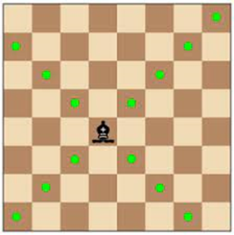

**The Queen**

The queen may move to any square along the file, the rank or a diagonal on which it stands (FIDE rules). Basically, the queen move combines rook and rook moves. The queen cannot jump over other pieces, but can capture a piece. The queen is one of the most valuable chess pieces.

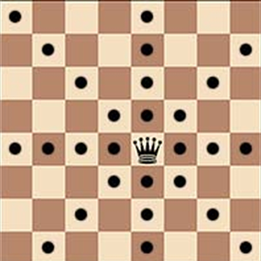

Remember: when making these moves the bishop, rook or queen may not move over any intervening pieces.

**The King**

There are two different ways of moving the king: first, by moving to any adjoining square not attacked by one or more of the opponent’s pieces. In another words: the knight may move to one of the squares nearest to that on which it stands. (FIDE rules)

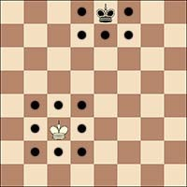

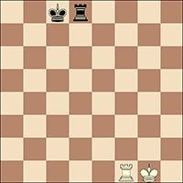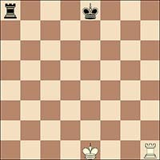The other way of the king is so called ‘castling’. This is a move of the king and either rook of the same colour along the player’s first rank, counting as a single move of the king and executed as follows: the king is transferred from its original square two squares towards the rook on its original square, then that rook is transferred to the square the king has just crossed.

***Before white kingside castling After white kingside castling***

***Before black queenside castling After black queenside castling***

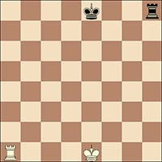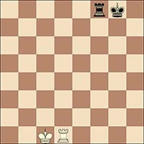

***Before white queenside castling After white queenside castling***

***Before black kingside castling After black kingside castling***

The right to castle has been lost:

a. if the king has already moved, or

b. with a rook that has already moved.

Castling is prevented temporarily:

1. if the square on which the king stands, or the square which it must cross, or the square which it is to occupy, is attacked by one or more of the opponent's pieces, or
2. if there is any piece between the king and the rook with which castling is to be effected (FIDE rules)

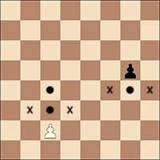**The Pawn.**

The Pawn moves directly forward to the unoccupied square, never backward or to the side. Pawns move exactly one square forward; though each Pawn may advance two squares forward the first time it is moved, if both squares are unoccupied. Pawns capture a piece that is one square diagonally forward.

**Zugzwang.**

Zugzwang is a German word which translates to "compulsion to move."Zugzwangbasically means, "It is your turn to move, and all of your moves are bad!" There is no "pass" or "skip a move" in chess, so sometimes having to move can lose the game! (chess.com)

Remember. Learning the game of chess is easy, but learning to play chess well is difficult, because "Chess is the art of analysis." (Mikhail Botvinnik, The sixth [World Chess Champion](https://en.wikipedia.org/wiki/World_Chess_Champion)).